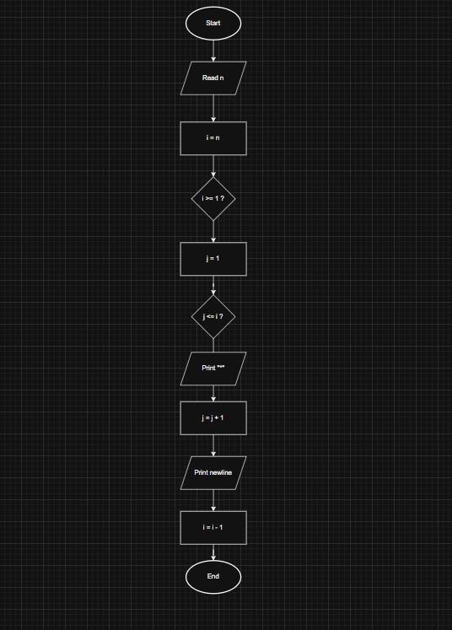
EXPERIMENT
-

7

Name : Atharva

PRN : 25070521137

7
.1.
1
]

Inverted Star Pattern

A)
ALGORITH
M

Step 1:

Start

Step 2:

Read an integer n (number of rows).

Step 3:

Initialize a loop from i = n down to 1 (decrement by 1 each time).

Step 4:

For each value of i, print i stars (*) in the same line without spaces.

Step 5:

Move to the next line after printing stars.

Step 6:

Repeat Steps 3 to 5 until i becomes 0.

Step 7:

Stop

B)
PYTHON CODE

n = int(input())

for i in range(n, 0,
-
1):

print("*" * i)

C)
FLOWCHART

